Please upload your solutions into github and me the link. Thank you.

**\*\*Problem 1:\*\***

Given a string _s_, find the longest palindromic substring in _s_. You may assume that the maximum length of _s_ is 1000.

**\*\*Solution?:\*\***

Write a Spring Boot micro-service that completes the following:

1. Receives string input over an API

2. Stores the longest palindrome in provided database

3. Retrieves the stored palindrome over an API

You should be able to run your micro-service locally and use an API client (such as PostMan) to test your results.

**Problem 2/Solution?:**

Have the function BinaryReversal(str) take the str parameter being passed, which will be a positive integer, take its binary representation (padded to the nearest N * 8 bits), reverse that string of bits, and then finally return the new reversed string in decimal form. For example: if str is "47" then the binary version of this integer is 101111 but we pad it to be 00101111. Your program should reverse this binary string which then becomes: 11110100 and then finally return the decimal version of this string, which is 244.

Problem 1: Solution

[http://localhost:3000/asgfsgdjgtrvkjjgkuv**madam**kjkhjuyfikiufkuyfasgfsgd](http://localhost:3000/asgfsgdjgtrvkjjgkuvmadamkjkhjuyfikiufkuyfasgfsgd) (endpoint which prints palindrome number)

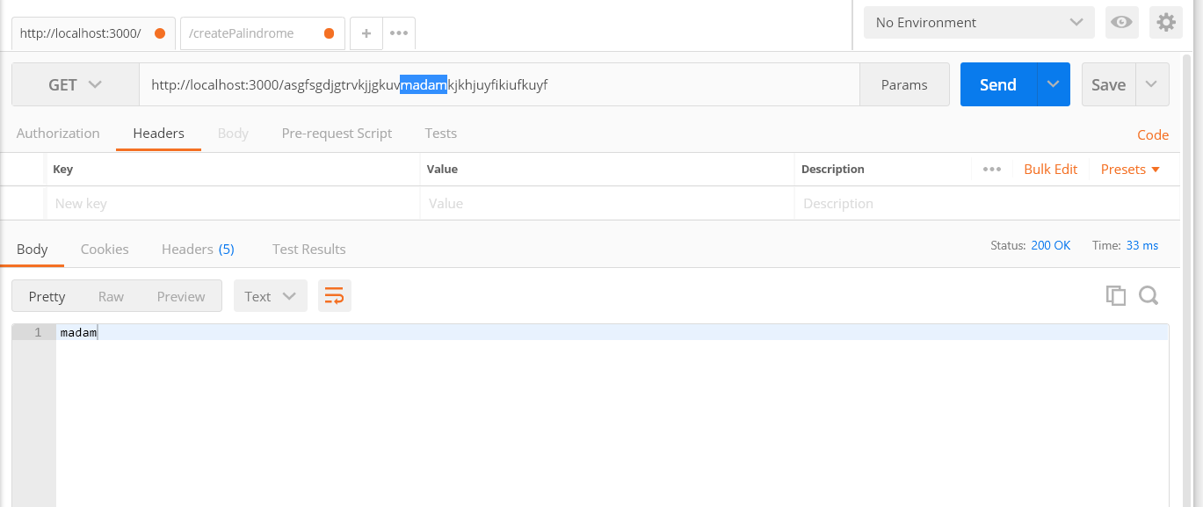

Below evidence showing API doesn’t accept if length is greater than 1000.

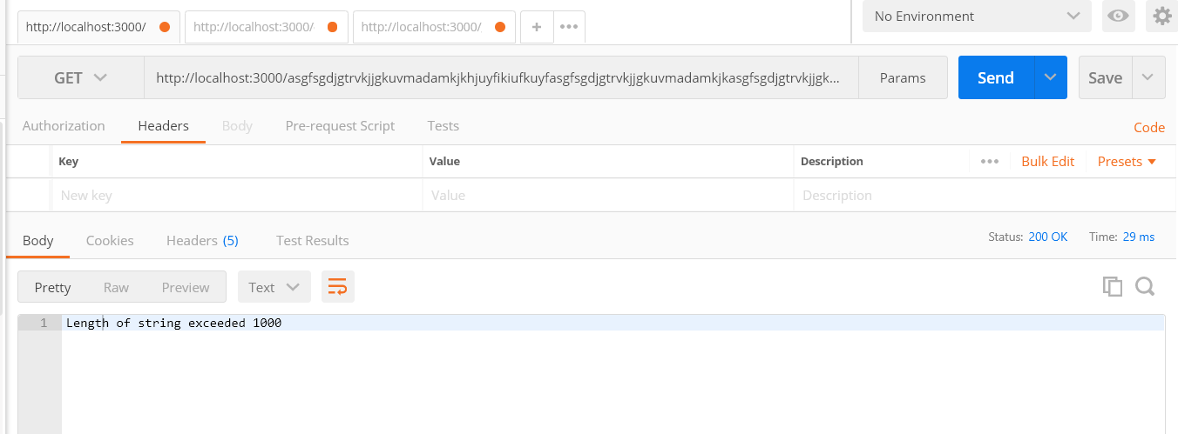

POST endpoint <http://localhost:3000/createPalindrome> endpoint which gives palindrome in response and also stores in DB.

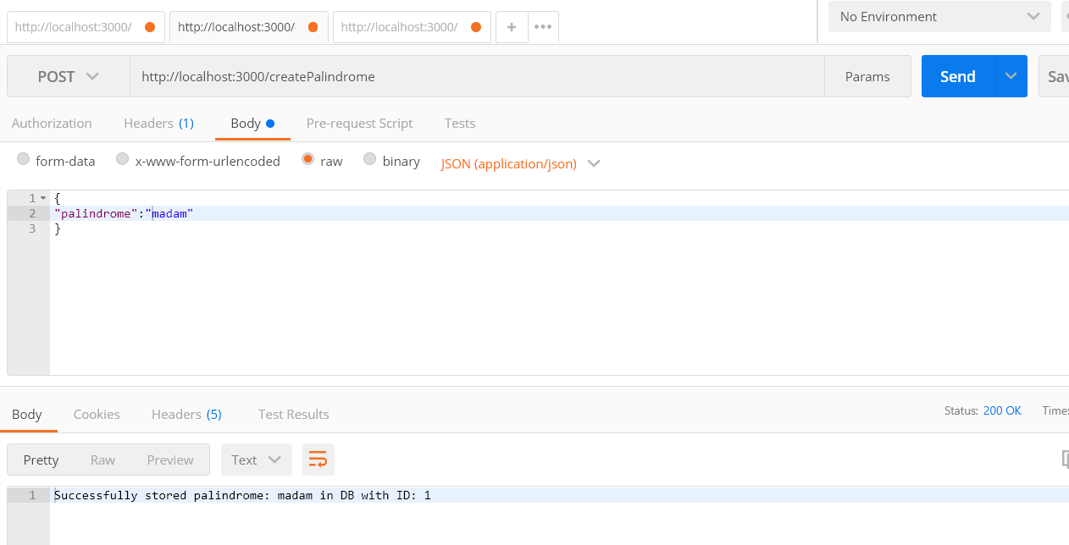

Get Endpoint <http://localhost:3000/getpalindrome/1> which can be used to retrieve stored palindrome from Database

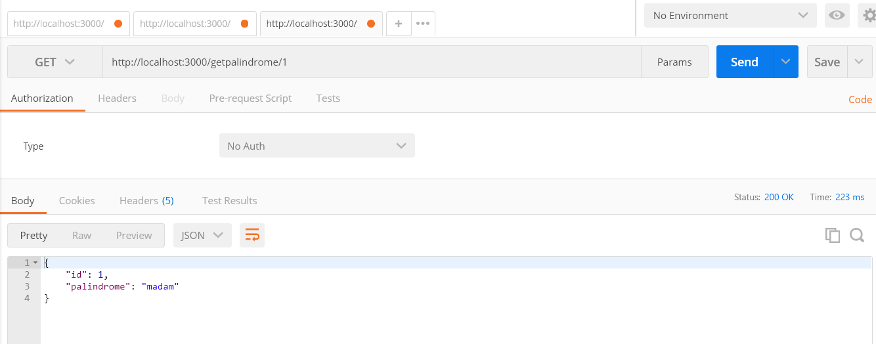

Program to BinaryReversal.

